7.2.17 Editors - 3D View - Tool Shelf - Armature - Edit Mode
Tool Shelf - Armature - Edit Mode 3
Tweak, Select, 3D Cursor, Transform, Annotate and Measure 3
Roll 3
Snapping 3
Precision movement 3
Header Values 3
Tool Settings 3
Drag 3
Active Tool 3
Tweak, Select Box, Circle and Lasso 3
Last Operator Transform 4
Values X, Y Z 4
Axis 4
Orientation 4
Proportional editing 4
Proportional Falloff 4
Proportional Size 4
Connected 4
Projected(2D) 4
Bone Size / Envelope Tools group 4
Bone Size 4
Snapping 5
Precision movement 5
Header Values 5
Tool Settings 5
Drag 5
Active Tool 5
Tweak, Select Box, Circle and Lasso 5
Last Operator Transform 5
Values X, Y Z 5
Axis 5
Orientation 5
Proportional editing 6
Proportional Falloff 6
Proportional Size 6
Connected 6
Projected(2D) 6
Bone Envelope 6
Snapping 6
Precision movement 6
Header Values 6
Tool Settings 6
Drag 7
Active Tool 7
Tweak, Select Box, Circle and Lasso 7
Last Operator Transform 7
Values X, Y Z 7
Axis 7
Orientation 7
Proportional editing 7
Proportional Falloff 7
Proportional Size 7
Connected 7
Projected(2D) 8
Extrude Tools group 8
Snapping 8
Precision movement 8
Header Values 8
Move without Widget 8
Limit Axis 8
Extrude 9
Tool Settings 9
Axis Type 9
Drag 9
Active Tool 9
Tweak, Select Box, Circle and Lasso 9
Last Operator Extrude 10
Forked 10
Move X , Y, Z 10
Orientation 10
Proportional editing 10
Extrude to cursor 10
Shear 10
Tool Settings 11
Orientation 11
Drag 11
Active Tool 11
Tweak, Select Box, Circle and Lasso 11
Last Operator Shear 11
Offset 11
Axis 11
Axis Ortho 11
Orientation 11
Proportional editing 11
Proportional Falloff 11
Proportional Size 12
Connected 12
Projected(2D) 12

Tool Shelf - Armature - Edit Mode
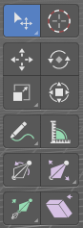
Here you find some tools to edit and extend the armature.

Tweak, Select, 3D Cursor, Transform, Annotate and Measure

The tweak, select, 3D cursor and transform tools and the annotation and measure tool is already described in the chapter Object Mode. So we won't cover it here again.

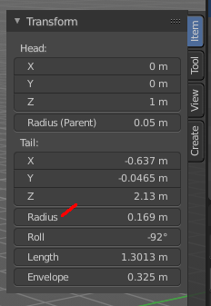
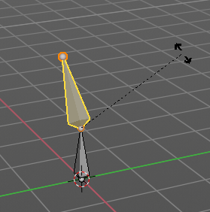
Roll
Adjust the bone roll of the selected bone(s).

Snapping
Rotate and holding down Ctrl activates temporary global snapping. The rotation snaps every 5 degrees. With holding shift too it snaps every 1 degree.

Precision movement
When you hold down shift, then you will have a much slower but also much preciser rotation.

Header Values
When you move the mouse then you will see some values in the header, which shows the current rotation factor. This value is relative to the starting value, which always starts with 0.

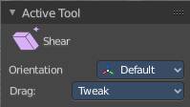
Tool Settings

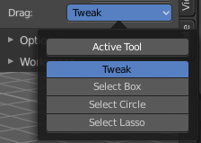
Drag
When you click at the widget of the active tool, then you perform the tool action. Adjust what should happen when you click outside of the widget, in the empty area.

Active Tool
When you click off the widget then the click still does the same than clicking at the widget. It performs the active tool.

Tweak, Select Box, Circle and Lasso
When you choose this options then you will set the off click to the different select methods. Whereas tweak works more than a move tool then. Tweak is the default.

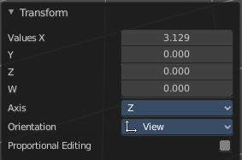
Last Operator Transform

Values X, Y Z
The rotation. Attention, the actual world orientation and rotation does not matter here. It always starts with a value of zero, and moves relative to this zero then. For the actual location values have a look in the sidebar in the transform panel.
The only relevant setting here is Value X. All other values and settings does not have any effect.

Axis
The axis to use. Axis has no effect, the bone axis X is always used.


Orientation
The widget can have different orientations. The menu items should be self explaining.
Orientation has no effect, the bone axis X is always used.


Proportional editing
Enables proportional editing. Activating proportional editing reveals further settings.

Proportional Falloff
Adjust the falloff methods.

Proportional Size
See and adjust the falloff radius.

Connected
The proportional falloff gets calculated for connected parts only.

Projected(2D)
The proportional falloff gets calculated in the screen space. Depth doesn't play a role. When it's in the radius, then it gets calculated.

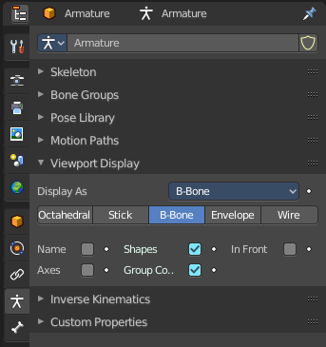
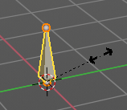
Bone Size / Envelope Tools group

Bone Size
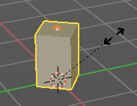
This tool just works with bone display type Bbone. With other bone display types nothing happens. Here you can scale the bbones.
The bone display can be changed in the properties editor in the Object Data tab in the Viewport Display panel.

Snapping
Move and holding down Ctrl activates temporary global snapping. The rotation snaps every 5 degrees. With holding shift too it snaps every 1 degree.

Precision movement
When you hold down shift, then you will have a much slower but also much preciser rotation.

Header Values
When you move the mouse then you will see some values in the header, which shows the current rotation factor. This value is relative to the starting value, which always starts with 0.

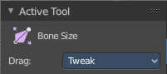
Tool Settings

Drag
When you click at the widget of the active tool, then you perform the tool action. Adjust what should happen when you click outside of the widget, in the empty area.

Active Tool
When you click off the widget then the click still does the same than clicking at the widget. It performs the active tool.

Tweak, Select Box, Circle and Lasso
When you choose this options then you will set the off click to the different select methods. Whereas tweak works more than a move tool then. Tweak is the default.

Last Operator Transform

Values X, Y Z
The rotation. Attention, the actual world orientation and rotation does not matter here. It always starts with a value of zero, and moves relative to this zero then. For the actual location values have a look in the sidebar in the transform panel.
The only relevant setting here is Value X. All other values and settings does not have any effect.

Axis
The axis to use. Axis has no effect, the bone axis X is always used.

Orientation
The widget can have different orientations. The menu items should be self explaining.
Orientation has no effect, the bone axis X is always used.

Proportional editing
Enables proportional editing. Activating proportional editing reveals further settings.

Proportional Falloff
Adjust the falloff methods.

Proportional Size
See and adjust the falloff radius.

Connected
The proportional falloff gets calculated for connected parts only.

Projected(2D)
The proportional falloff gets calculated in the screen space. Depth doesn't play a role. When it's in the radius, then it gets calculated.
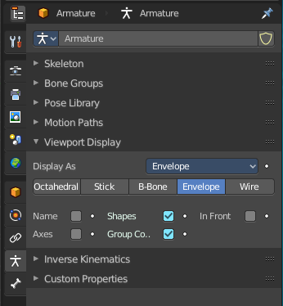

Bone Envelope
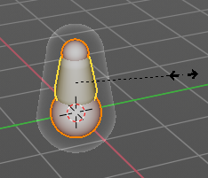
This tool just works with bone display type Bbone. With other bone display types nothing happens. Here you can scale the envelope of the bones.
The bone display can be changed in the properties editor in the Object Data tab in the Viewport Display panel.

Snapping
Move and holding down Ctrl activates temporary global snapping. The rotation snaps every 5 degrees. With holding shift too it snaps every 1 degree.

Precision movement
When you hold down shift, then you will have a much slower but also much preciser rotation.

Header Values
When you move the mouse then you will see some values in the header, which shows the current rotation factor. This value is relative to the starting value, which always starts with 0.

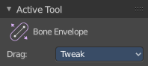
Tool Settings

Drag
When you click at the widget of the active tool, then you perform the tool action. Adjust what should happen when you click outside of the widget, in the empty area.

Active Tool
When you click off the widget then the click still does the same than clicking at the widget. It performs the active tool.

Tweak, Select Box, Circle and Lasso
When you choose this options then you will set the off click to the different select methods. Whereas tweak works more than a move tool then. Tweak is the default.

Last Operator Transform

Values X, Y Z
The rotation. Attention, the actual world orientation and rotation does not matter here. It always starts with a value of zero, and moves relative to this zero then. For the actual location values have a look in the sidebar in the transform panel.
The only relevant setting here is Value X. All other values and settings does not have any effect.

Axis
The axis to use. Axis has no effect, the bone axis X is always used.

Orientation
The widget can have different orientations. The menu items should be self explaining.
Orientation has no effect, the bone axis X is always used.

Proportional editing
Enables proportional editing. Activating proportional editing reveals further settings.

Proportional Falloff
Adjust the falloff methods.

Proportional Size
See and adjust the falloff radius.

Connected
The proportional falloff gets calculated for connected parts only.

Projected(2D)
The proportional falloff gets calculated in the screen space. Depth doesn't play a role. When it's in the radius, then it gets calculated.

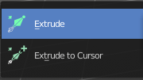
Extrude Tools group

This group contains some extrude tools.
There are some general settings, since they all have some move settings We will cover them all here for all of the tools.

Snapping
Holding down Ctrl activates temporary global snapping.

Precision movement
When you hold down shift, then you will have a much slower but also much preciser movement.

Header Values
When you move your object then you will see some values in the header, which defines the current position of the object.
The value m stands for the default metric system. Meters. You can change the units in the Properties editor in the Scene properties in the Units panel. When you choose kilometers here then you will see a km instead m.
The value D stands for the distance of the current selected axis. This can also be two axis. Then you have two d values. The value in the brackets is then the direct distance to the starting point.
These values are always relative to the starting point. You always start with zero, regardless of the real world position.

Move without Widget
You don't have to use the widget to move the object. You can also click aside of it, and drag the object around. The mouse turns into a move cursor. The standard behaviour then is to move in screen space. When you want to move into a specific axis, then press X or Y or Z to limit the movement to this axis.

Limit Axis
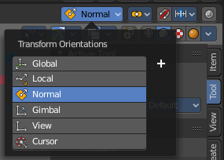
When you want to move along a specific axis, then press X or Y or Z to limit the movement to this axis. You usually start in global orientation. But you can change this in the Orientation settings.
By holding down the mouse button and pressing the X, Y or Z key twice you can toggle this to local. But also to other orientations. This depends in what orientation you start. With normal you can toggle that way between Normal and Global.

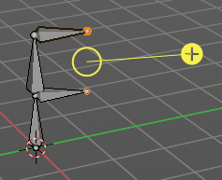
Extrude
The Extrude tool extrudes out bones from selected joints.
When you activate the tool, then you will by default see a yellow widget at the selection. Drag it to extrude the selection.

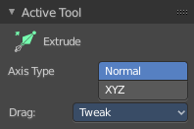
Tool Settings

Axis Type
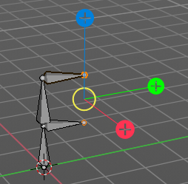
You can choose between the regular axis type. That's the yellow widget with just one handler. It always points in the direction of the middled normals of the selection.
Or you can use the XYZ axis type. That's a handler with three axis. This widget can be aligned with the transform orientation methods.

Drag
When you click at the widget of the active tool, then you perform the tool action. Adjust what should happen when you click outside of the widget, in the empty area.

Active Tool
When you click off the widget then the click still does the same than clicking at the widget. It performs the active tool.

Tweak, Select Box, Circle and Lasso
When you choose this options then you will set the off click to the different select methods. Whereas tweak works more than a move tool then. Tweak is the default.

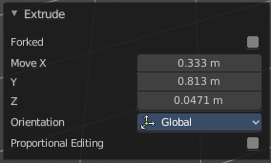
Last Operator Extrude

Forked
You need to tick X Axis Mirror. When you tick Forked, then the bone that you extrude to the one side will now be extruded to the other side too. The extrude gets mirrored along the x axis. This allows you to create a symmetrical armature.
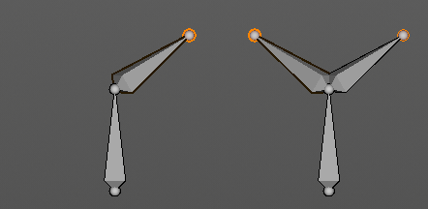
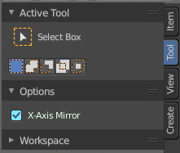

Move X , Y, Z
The transform values for the new created joint(s)


Orientation
Orientation is a drop-down box wChoose the type of orientation for the mirroring action.

Proportional editing
Proportional editing is disfunctional. You cannot activate it.

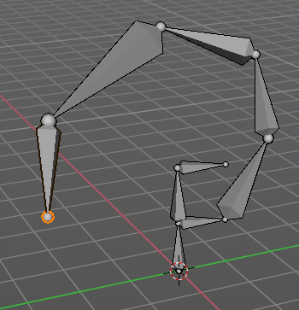
Extrude to cursor
Extrudes the selection towards the mouse cursor by clicking and dragging The extruded geometry will rotate towards the mouse pointer.

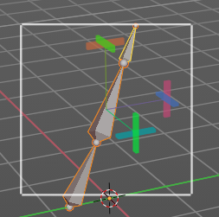
Shear
Shear shears the selection. When you activate the tool then you will reveal a widget. This widget allows you to shear the selection in all possible axis.

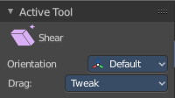
Tool Settings

Orientation
Choose the orientation for the shear action.

Drag
When you click at the widget of the active tool, then you perform the tool action. Adjust what should happen when you click outside of the widget, in the empty area.

Active Tool
When you click off the widget then the click still does the same than clicking at the widget. It performs the active tool.

Tweak, Select Box, Circle and Lasso
When you choose this options then you will set the off click to the different select methods. Whereas tweak works more than a move tool then. Tweak is the default.

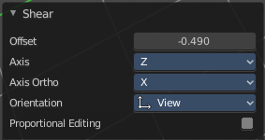
Last Operator Shear

Offset
Adjust an offset.

Axis
Defines one axis of the imaginary shear axis plane.

Axis Ortho
Defines the other axis of the imaginary shear axis plane.

Orientation
Choose the orientation for the shear action.

Proportional editing
Enables proportional editing. Activating proportional editing reveals further settings.

Proportional Falloff
Adjust the falloff methods.

Proportional Size
See and adjust the falloff radius.

Connected
The proportional falloff gets calculated for connected parts only.

Projected(2D)
The proportional falloff gets calculated in the screen space. Depth doesn't play a role. When it's in the radius, then it gets calculated.

